**DAILY ONLINE ACTIVITIES SUMMARY**

|  |  |  |  |  |  |  |  |
| --- | --- | --- | --- | --- | --- | --- | --- |
| **Date:** | **14/06/2020** | | | | **Name:** | **K ISHA HEGDE** | |
| **Sem & Sec** | **4th & ‘A’** | | | | **USN:** | **4al18cs031** | |
| **Online Test Summary** | | | | | | | |
| **Subject** | | **--** | | | | | |
| **Max. Marks** | | **--** | | **Score** | | **--** | |
| **Certification Course Summary** | | | | | | | |
| **Course** | **INTRODUCTION TO ETHICAL HACKING** | | | | | | |
| **Certificate Provider** | | | **GREAT LEARNING** | **Duration** | | | **4.5 HRS.** |
| **Coding Challenges** | | | | | | | |
| **Problem Statement:1)** Write a C program to remove specific characters in the String | | | | | | | |
| **Status: complied** | | | | | | | |
| **Uploaded the report in Github** | | | | **yes** | | | |
| **If yes Repository name** | | | | **[https://github.com/iishaii/locked-down_coding](https://github.com/iishaii/locked-down_coding" \o "https://github.com/iishaii/locked-down_coding)** | | | |
| **Uploaded the report in slack** | | | | **yes** | | | |

Online Test Details: (Attach the snapshot and briefly write the report for the same)

Certification Course Details: (Attach the snapshot and briefly write the report for the same)

Today I started with INTRODUCTION TO ETHICAL HACKING from great learning . It was of 4.5hrs. I completed the entire course and also attempted the quiz which gave me clear view about the topic .I also secured a certificate

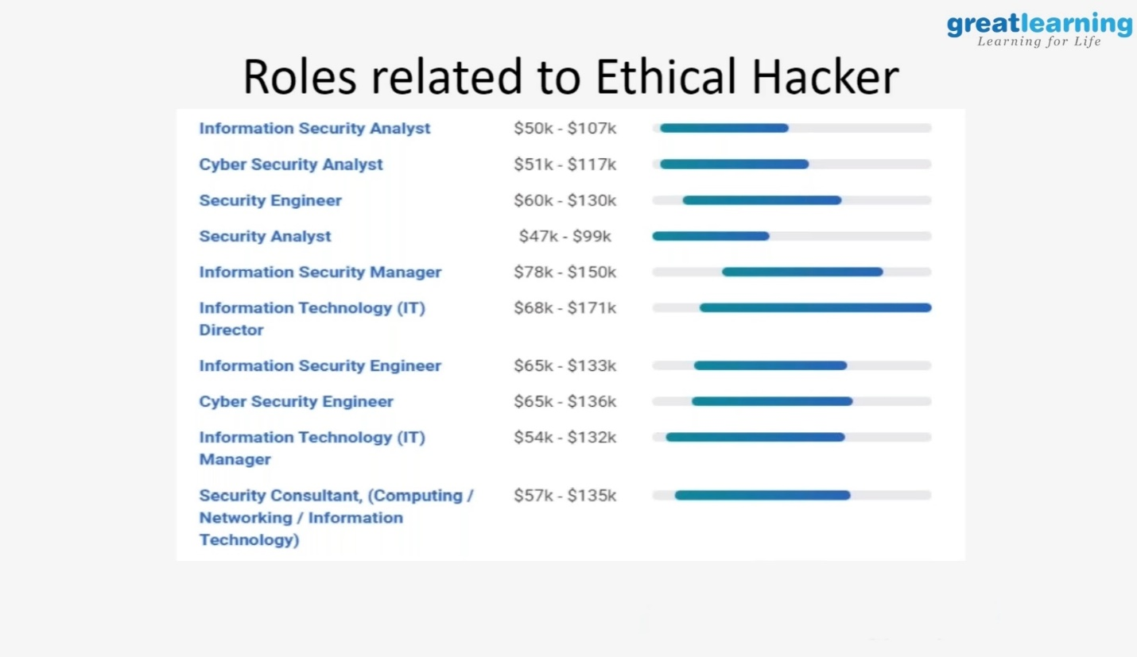

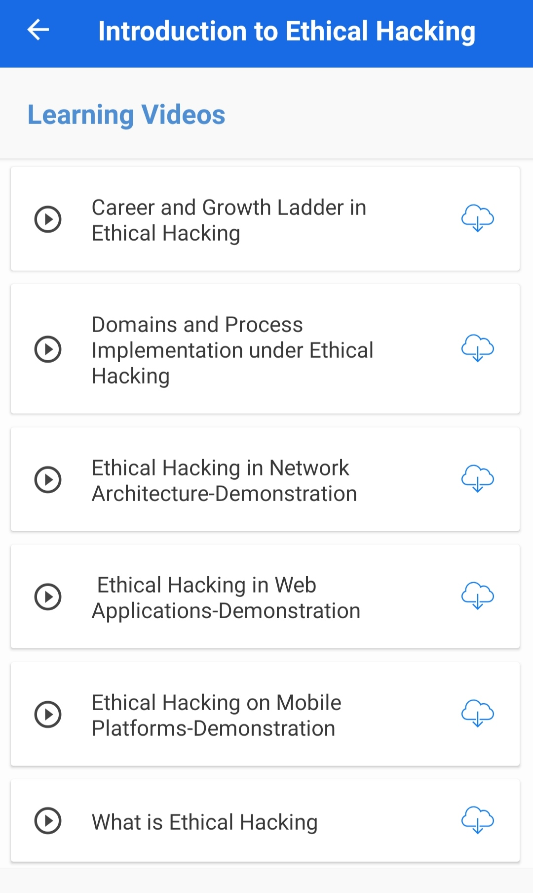

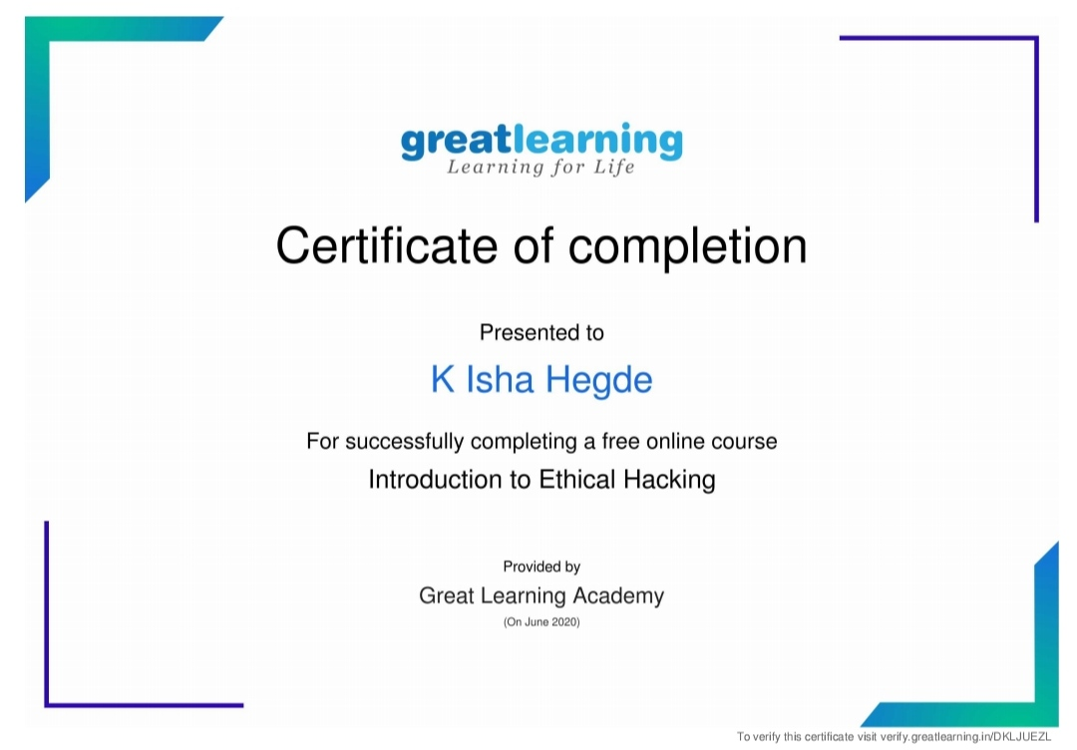

Coding Challenges Details: (Attach the snapshot and briefly write the report for the same)

Program 1: Write a C program to remove specific characters in the String

Example  
If the original string is "Welcome to AIET" and the user inputs string to remove "co" then the it should print "Welme to AIET" as output .

**Input**  
First line read a string  
Second line read key character to be removed.

**Output**  
String which doesn't contain key character.

I have uploaded the solution in github.

[https://github.com/iishaii/locked-down_coding](https://github.com/iishaii/locked-down_coding" \o "https://github.com/iishaii/locked-down_coding)

